West Hull Ladies
RRC

September Newsletter
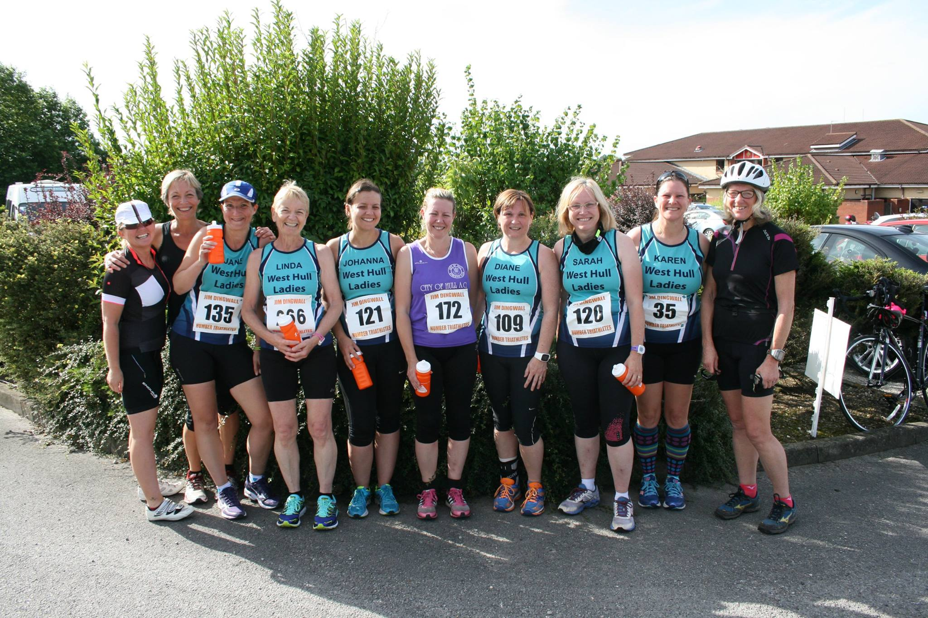

Elloughton 10K
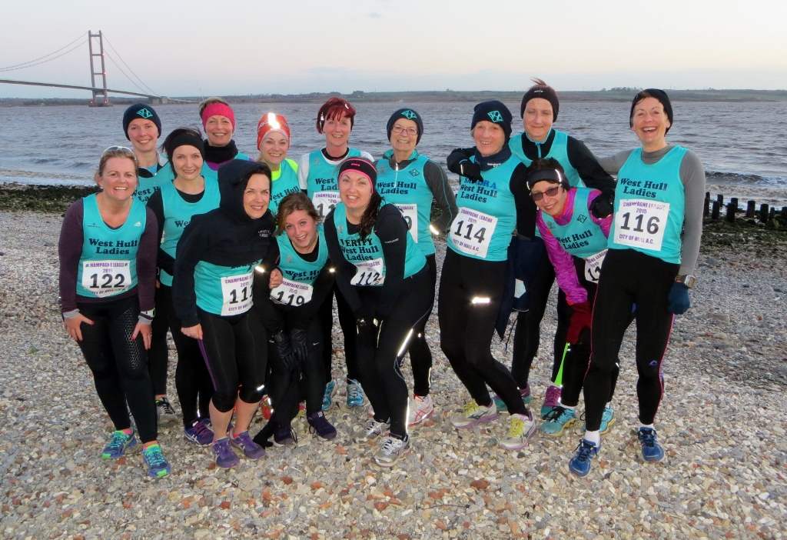

Champagne League
Read all about it, page 11 onwards

West Hull Ladies
Committee Meeting 7th September 2015 - Minutes
Present – Amanda, Zoe, Jill, Linda, Liz D, Maria, Jan (speakerphone for item 4)

- Apologies from Annette, Karen, Anna and Sandra.
- Minutes of previous meeting accepted as true record
- Matters arising
  - Yorkshire Vets. Action Jill to continue enquiries.
  - The club name is still appearing as West Hull Runners for some race registrations.
  - Jill had sought expressions of interest for Endure 24 and the Thunder Run in 2016. Two teams of five, and one pair, are expected for Endure.
  - Anna had contacted all Hull Marathon relay runners.
  - The WHL banner has been ordered and paid for.
  - Friday training reps. Action Amanda to send an email reminder that the set training is not compulsory and ladies are welcome to arrange their own runs.
- Jan suggested three ideas for social events: occasional away nights, with a bar meal afterwards; an annual weekend away; and a Hull Marathon ‘after party’ at Pave for all involved in the race. The committee agreed with all the ideas, and suggested that other clubs be invited to the after party and that all runners wear their Hull Marathon t-shirt. Away nights are more difficult in autumn due to lack of light, but it was agreed that a night of head torch practice would benefit ladies running Endure and TR24. Action Jan to research venues for a weekend away, possibly next spring. Action Jan to arrange the marathon after party, and post on Hull Runners Facebook page. Action Jan to arrange away night.

- The race page on the website is out of date. Action Zoe to update.
- Amanda suggested sharing the responsibilities for next year’s edition of the 0-5k between several ladies. There is enough support from leaders to run the 6 week programme, but more commitment is needed to support new ladies after they have completed the 0-5k. Help is also needed for recruitment, advertising, and dealing with application forms. Action Amanda to list what is needed for the October agenda.
- AOB
  - The website and kit form need to be updated with how to order new kit. Action Amanda to update using the information currently on Facebook.
  - Action Amanda to pin a jpg image of the September training to the top of the Facebook group.
  - White City marathon pasta party. Action Amanda to send thank you email to White City.
  - Champagne League presentation evening. Action Jill to send thank you email to City of Hull.
  - 100k club. Jill suggested that this could be printed straight onto vests.
  - Track sessions. Action Amanda to email Debbie and Sara about reinstating track sessions once a month.
  - YPI. Amanda had emailed the YPI with a list of requests. The whole building is also now closed on Friday’s at 6pm. Action Amanda to chase up.

Marathon Recovery

Marathon recovery begins the minute you cross the finish line. Keep walking after you cross the finish line to allow your body to return to its resting state gradually. Get your medal, take your photos, pick up your gear and keep walking. It will allow your heart rate and blood flow to return to its normal state as well as reduce the risk of blood pooling in your legs which can cause fainting. Get up and walk around 10 to 15 minutes every few hours for the rest of the day.

Refuel depleted muscles as soon as possible with a meal that includes carbohydrates, protein and sodium. Fuel is most efficiently absorbed in the first 30 to 60 minutes post-race. A peanut butter and jam sandwich, banana and sports drink is one example. If you struggle with eating post-race, try liquid recovery drinks which are formulated with everything you need to refuel your body--carbohydrates, protein, electrolytes and fluid.

The stress of running a marathon can depress your immune system, leaving you susceptible to colds, flu and other upper respiratory tract infections in the days immediately following the race. Self-care is the best way to reduce your risk of contracting a virus, so make sure you get plenty of sleep, eat well-balanced meals and drink lots of water.

A general lack of energy in the week following marathon is perfectly usual. Try to eat meals comprising 50-60 per cent carbohydrates to replenish your glycogen reserves, and foods rich in protein to assist your body in repairing muscle and tissue. Indulge any cravings you might have – these could be your body’s way of telling you what it needs. Scientific research also indicates that many marathon runners lose around 3mg of iron per day for up to five days after the marathon, so eat foods rich in iron: meat, spinach, beans, peaches, parsley and peas during your post-marathon week. To promote iron absorption, consume other rich sources of vitamin C with your meals.
Some runners complain of weight gain immediately after a marathon. This is most likely due to water retention as your muscles repair and rebuild. Don’t be tempted to start (or resume) any weight-loss regime during this time – your body requires a full complement of nutrients to recover from the stress of the race. Of course, if you are still gaining weight after your first recovery week, you might want to consider adjusting your calorie intake to suit your new activity levels.

Tapering in Reverse
Just as you tapered off with decreasing weekly mileage in the weeks just prior to the marathon you need to do the opposite after the race. Here is a typical post race schedule:

Week 1:
Mon | Tue | Wed | Thu | Fri | Sat | Sun
Walk | Walk | 3M | Walk | Rest | 4M | Walk
Week 2:
Mon | Tue | Wed | Thu | Fri | Sat | Sun
3M | Rest | 5M | Walk | Rest | 6M | Walk

WHL Just Giving

Sandra: Crohns and Colitis UK

I am running 3 marathons and so far I have completed Boston (April 2015) and on the 27th September 2015 I shall be running Berlin and in April 2016 London. Having run York in October 2014 I will by the time I have finished run a marathon every 6 months. As many of you know the hard part of the Marathon is the training and I can tell you that is does not get any easier. However when I am running I do think of what I am fundraising for - no matter the hard work it is nothing in comparison with what sufferers of this disease live with everyday.
Why did I pick Crohn's and Colitis?
It was a massive support to me when my daughter was first diagnosed with Crohns just after I ran the London Marathon in 2012. For an adult it is a horrible chronic (lifelong) disease but for a teenager it can be overwhelming and it is certainly life changing. Your health is never something to take for granted.
The charity works to support all those affected by inflammatory bowel diseases to achieve a better quality of life, improve services and ultimately find a cure.
More and more young people are being diagnosed with the disease and I feel that the charity needs all the help it can get not only to try and find a cure but to raise awareness. Most people can look well on the outside but they are far from that.

Any donations would be gratefully accepted - every single £1 would be of a great help.
I do have a justgiving page if anyone would like to make a donation
www.justgiving.com/Sandra-Holdsworth/
Many thanks
Sandra

Tracy: Cancer Research UK

As most of you know I run alot, I'm a member of an amazing running club, which is WHL (West Hull Ladies). I joined this club August 2014 never thinking that 1 year on I would be running a marathon! The support & encouragement from this club is amazing, I wouldn't have got this far without them.
Running a marathon is something that's always been on my 'bucket list'. Through all the hard work in training to marathon level I've decided that I would like use this opportunity to raise some cash for a worthy cause ... Cancer Research UK - a charity that is always in need of more cash to help find a cure for this dreaded disease.
I'm sure you know someone who has suffered from cancer and that's why I'm asking for your help in raising as much as I can for a great cause!
Please give what you can afford.
https://www.justgiving.com/TracyToner-HullMarathon/
Cheers guys
Tracy x

Meet a Member: Linda Dodsworth

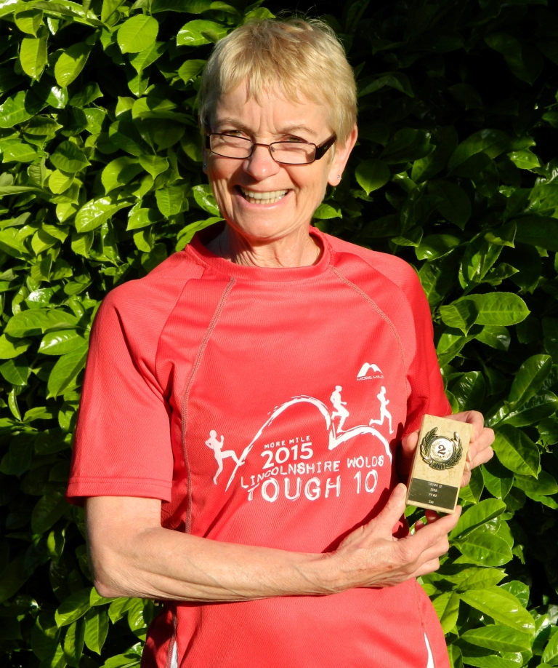

Age 61
Member of WHL since – June 2013
What do you do when you’re not running? – I love to be in my craft room creating memory albums or cards. I enjoy walking and spend a lot of time walking Oliver my 5 year old Boxer.
How long have you been running? I started in my 30’s but didn’t keep it up.
Why did you start running? I always said that I would run a marathon in my 60th year so started training the day after my 59th birthday!
Favourite distance Hard this one but I do like a good 10 miler or half marathon the best.
Favourite bit of running kit My WHL running vest, I love pulling that on on race day. I also love my Garmin watch.
Any injuries? No, thankfully.
Running goals? To run the London Marathon, which I hope to achieve in 2016.
Proudest moment running related or otherwise Being a part of WHL during and after the North Lincs half marathon this year. Peter Draper’s poem he wrote says it all for me and whenever I read it (I do this often), it makes me tear up! I know I’m a softie.
Best piece of advice you’ve received How to breath properly, thank you so much Amanda Dean!
Running alone or with friends? I always used to like running alone or with music but I don’t anymore, I love to run with you ladies whenever I can and I class you all as ‘friends’.
What keeps you motivated? All the lovely ladies that belong to our awesome club.

Meet a Member: Zoe Jameson
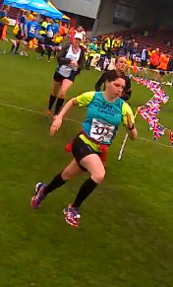
Age – 26
Member of WHL since – Feb 2012
What do you do when you’re not running? Work with autistic adults. Like cycling, sewing, watching films, visiting new places, going for lunch with mum (especially when she is paying!), sleeping, motorcycle mechanics.
How long have you been running? Nearly 3.5 years (since joining WHL)
Why did you start running? Mum dragged me to WHL when she was too scared to go on her own for the first time. (I think she was trying to tell me that I needed to lose some weight?!)
Favourite distance The shorter the better as I love to sprint! Although I do like a challenge such as Thunder Run 24hr.
Favourite bit of running kit My full length Skins tights as they held my legs together throughout Thunder Run 24.
Any injuries? There is always a niggle somewhere but currently my right hamstring and achilles from over striding and running on my toes.
Running goals? Initially to run further than I have ever run before at Thunder Run 24. Then next year to get a PB at 10km (My PB stands at 48:22 from my second ever 10km at York 2012).
Proudest moment running related or otherwise: Winning the pairs Thunder Run 24 with Sally, having run 100km each. I was surprised to still be upright at the end and still can’t believe that we past the leading pair 1.5km from the end. It was amazing standing on the top step of the podium!
Best piece of advice you’ve received: Don’t put too much pressure on yourself, just relax and enjoy your running.
Running alone or with friends? Definitely with friends. Sometimes I don’t like to talk but I do like having someone there. In a race I like to run on the shoulder of either Debbie or Sandra, this gives me confidence as I am rubbish at pacing myself.
What keeps you motivated? – The support of my friends at WHL and the fact that mum is snapping at my heels!

Thunder Run – Endure
Dear members,
Re: Interest for participation in 24 hour races next year: Endure 24 Reading: June; thunder run Derbyshire: July; Equinox Leicestershire: September.
As you know we have had competitors at a number of 24 hour races in the past three years. These events are great fun to take part in as well as being quite challenging, but all in all we have a great time when we compete. These events however have to be planned and entered quite a long way in advance, usually the year before the actual event. Because of this, I am writing to you all to get an idea of who might be interested in competing next year.
Runners can compete as a pair, as a five, as an eight or as a solo runner. The cost is around £50 each, for each event, but that includes, camping over the weekend, parking, a nice tee shirt, a nice medal and a goody bag. Solos are more expensive however. Other costs include a contribution to food, around £13 - £20, depending on how many people are going, and a contribution to petrol if you are a passenger in a car.
Now to dispel some myths...
You don't have to be speedy, as it's best to be steady and keep going and we will do some practice sessions for runners. You don't need to have a tent, because we can usually sort out tent spaces for people, and we have lots of equipment. It would be best if you have your own sleeping bag and a mattress/air bed, but some people do have spares if you really can't get these. You will need a head torch to run during the night, and I would advise people to buy a good one, like those made by Silva, however, if these are beyond your budget, you could run round with a cheaper head torch plus a hand torch. Alternatively, you could share with someone if you are running in a team.
If you do not fancy running but would enjoy a camping weekend, you could come as crew and just contribute to food and travel, as it's really useful for us to have crew particularly for solos and pairs.
If you are interested in competing in one or more of these events or would like to find out more, please can you get in touch with Jill either by replying to this email or by emailing jillfireblade@live.co.uk.
Best wishes
Jill x
Major Stone Half Marathon: Linda
This day has to have been the hottest we’ve had so far this summer but it was really windy, the trees in my garden were almost bent double. I hate running in wind!

I was offered a lift to the event by a Radio Humberside Celebrity, James Piekos, he does live quite close to me and seeing as I’d told him about the event after he’d taken part in Walkington 10k he decided to enter. Me being me had entered this event twice apparently! Once by paper entry and then again on line, this getting older malarkey is no good, will have to try and do something about my brain!

A nice journey chatting to James and trying to persuade him to get WHL on the radio with the marathon coming up in a couple of weeks. He is going to try and do something along those lines seeing as we have so many competitors for a relatively small club. But the radio station that is ‘taking part’ in the marathon is KC FM so Radio Humberside isn’t really into the marathon, although they do have David Harrison who is a runner and taking part in the full marathon and he is also a ultra competitor! Anyway ladies I tried my hardest.

He met up with our other lovely ladies taking part, Jan, Liz, Jo, Di plus Ben who is Liz’s boyfriend, what a nice chap he is, and I introduced James to Richard and Phil from COH as he has decided he needs to join a club and couldn’t quite believe how friendly we all were to each other. Phil said a nice thing that really WHL was related to COH and they always made sure we were looked after. How nice.
Anyway the race got underway and boy was it hot! The wind was strong and warm, I’d just started and was regretting not having my own drinks supply with me although I knew there would be water stations. I tried to set off steady but it didn’t quite work out, I certainly did the first three miles way too quick (must remember not to make that mistake in the marathon). I didn’t need to go fast either as I was just using this run as a training run! The first three miles were ok, back wind which was nice then we turned a corner and the head wind hit, I dug deep though and kept going. The water station was a welcome sight and for the first time since entering races I stopped and walked and made sure I drank the whole cup instead of just taking a sip and throwing the rest away.

I was thoroughly enjoying the race and felt good until we got to mile 9, it felt as though someone had literally unplugged me and I felt myself slowing down. I was desperately in need of a drink too, thankfully that wasn’t so far away but I felt so bad I had to walk which is unlike me. I took two beakers of water and made sure I drank them all. It took until the next two miles for me to begin to feel myself again, then I got into a nice pace and felt much better. It was around this time that the wind was so strong a branch blew down in front of me, at the time a chap was running beside me so we were both lucky to not be hit on the head, especially as I hadn’t filled in the back of the number who my next of kin was. Not that it would have mattered because if they tried ringing him indoors he wouldn’t answer the phone anyway, he might have started missing me around tea time when there was no one to make his gravy for him!

Finally, hooray, the finish is in sight, seemed like such a long race, I was so hot and was ready for a long cool drink. I collapsed flat on my back on the grass verge till I got my breath back! Just got up to see Liz come in and not long after Jan (well done Jan hope your foot is ok), then we all waited until Di came in. Just one lady left out there in the heat so we walked until we found her and ran Jo into the finish to a big applause from WHL.

What a wonderful morning, great chatting and catching up with everyone and great to see that James had enjoyed himself being surrounded by WHL plus COH. Think he’s smitten to this running lark.
Linda
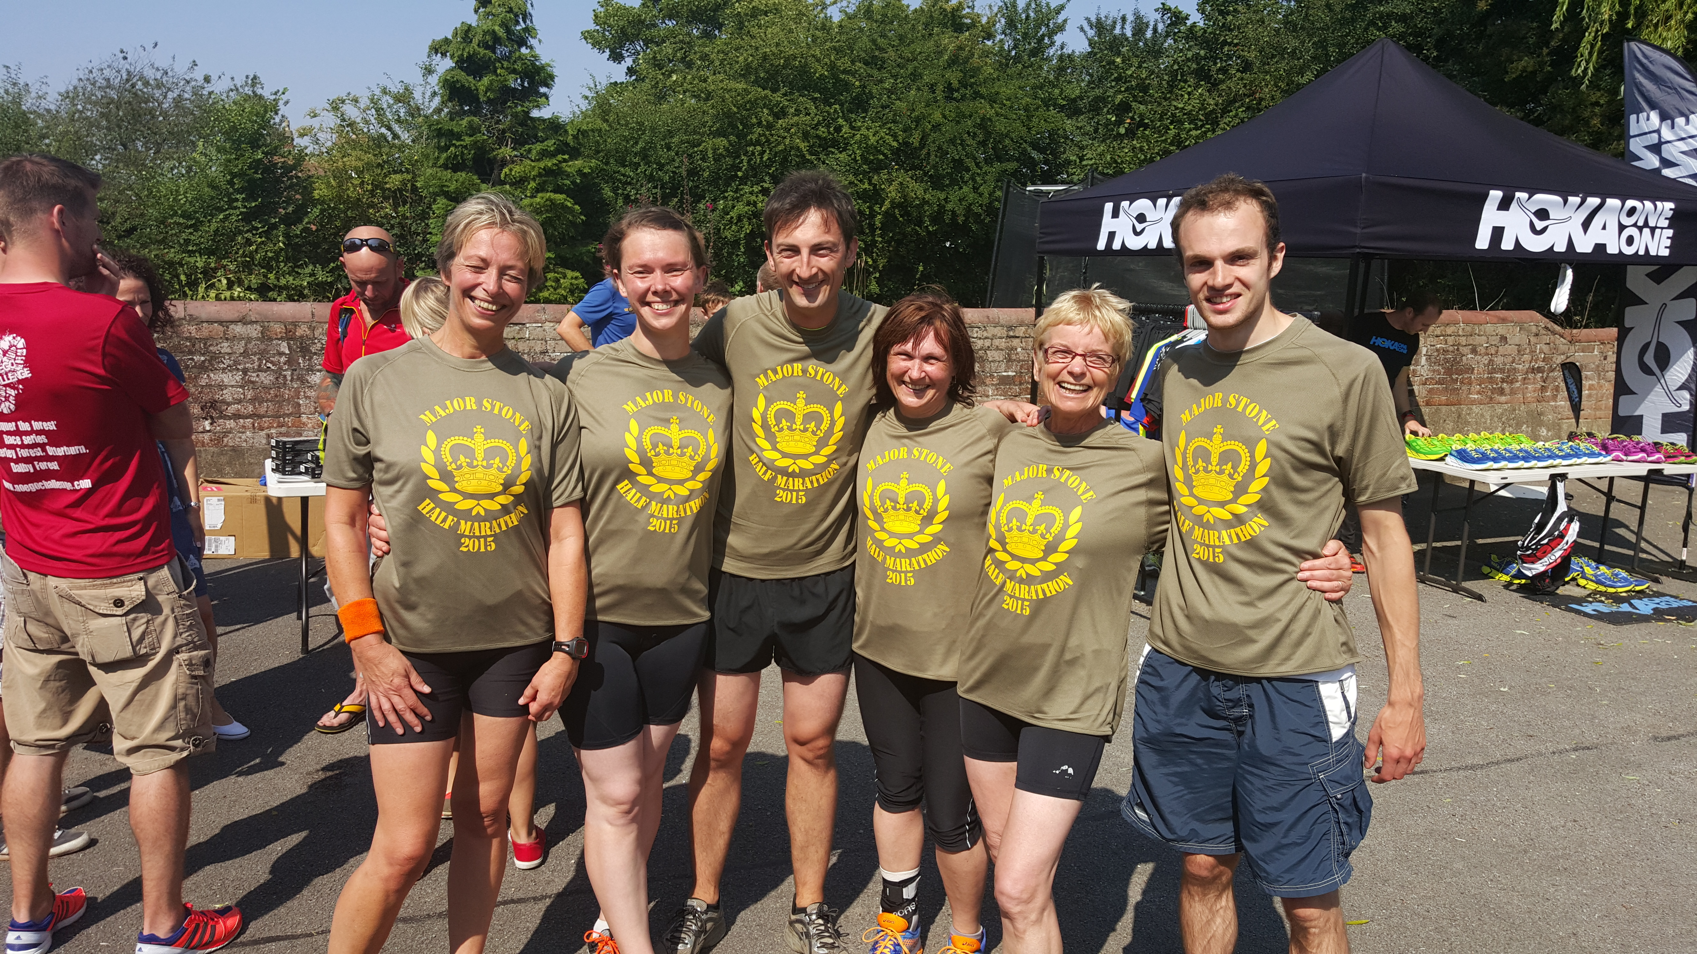

Ginger and Apple Cake Amanda (for Jane)

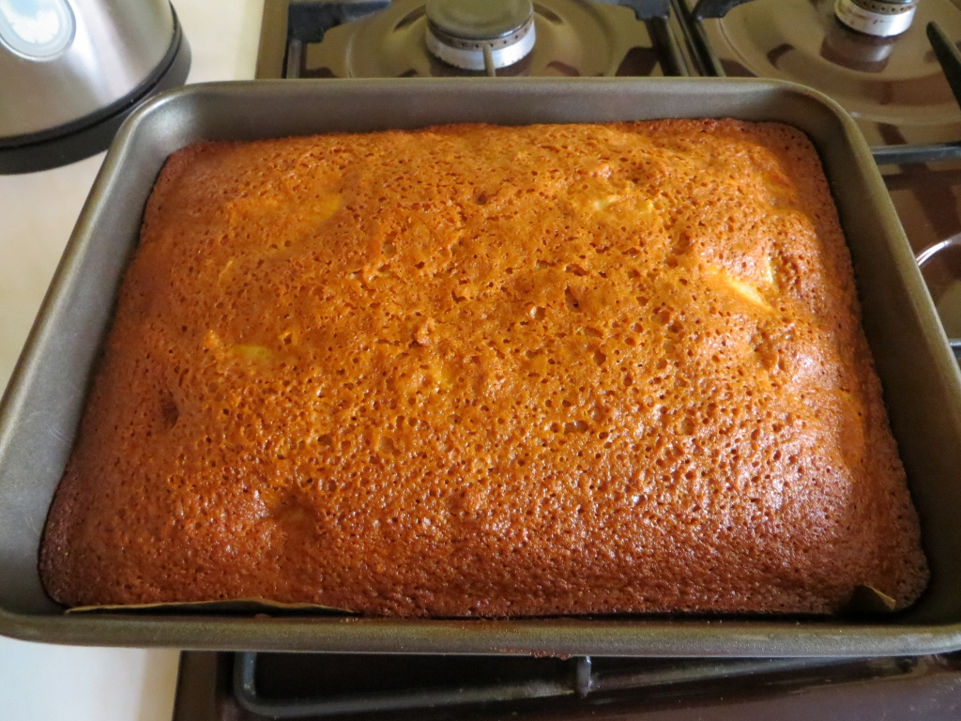

Ingredients

Approx 8oz (200g) cooked, chopped apples

1lb (400g) plain flour

8oz (200g) sugar

6oz (150g) butter

12oz (300g) syrup

¼ pint milk

1 egg

4 tsp ginger

½ tsp salt

2 tsp baking powder

½ tsp bicard

Method
- Warm slowly in a pan: syrup, butter, sugar.
- Sieve flour, ginger, salt, baking powder, bicarb. into large mixing dish.
- Stir apple into this dish.
- Beat egg in a cup.
- Warm milk don’t boil
- Combine all ingredients into the mixing dish beating as you go.
- Place in greased, lined oven dish. Bake 180C. Test with skewer after 30-40 mins. Continue cooking until skewer comes out clean.

All about the Champagne League

By Amanda et al

The Champagne League is a series of 10 races organised by City of Hull running club. It is a closed event with places allocated to local clubs e.g. Beverley Athletics, White City, East Hull Harriers.
West Hull Ladies were allocated 15 places this year. It is great to be racing with local clubs and to find out just how friendly everyone is. The races are run on Tuesday evenings from various scenic locations (see below). Many of the runs are off road or on quiet country roads.

Competitions and Prizes 2015

15 WHLs raced, 11 ladies got prizes! The four ladies who missed out on prizes were Sarah K, Debbie, Sally and Rachel W who had to miss races for various reasons, hopefully they still came away positive having had some good races and great training. In terms of handicap points, if you miss a race you get 0 points and your following race is given the minimum points. All ladies who completed all 10 races took at least one prize so well worth checking out your diary in advance.

We took a total of 19 prizes which is around half of the prizes available to ladies. We must have won a small fortune between us. Most competitions are based on handicaps so being fast is not relevant. The Yellow Jersey is based on speed and completing all 10 races, most people do not manage all 10 so if you can there is a good chance of a prize. In addition there are prizes for the fastest male and female in each race but we only have a chance in the two reversed handicapped races.

Jill was amazing taking 4 prizes, Verity not far behind with 3 prizes. Liz and Jan two prizes each. Leaving one each for Jane, Linda, Sandra, Zoe, Sara, Rach and Amanda.

Main Handicap

Top 12 got prizes

3rd Jill
5th Liz
11th Verity

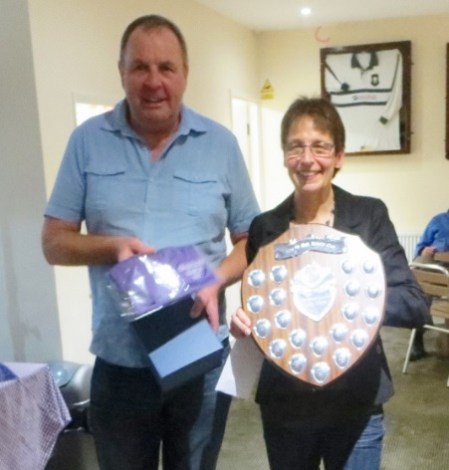
Peter Taylor Trophy
Ladies Handicap
Top 6 got prizes

1st Jill
5th Rach
6th Verity

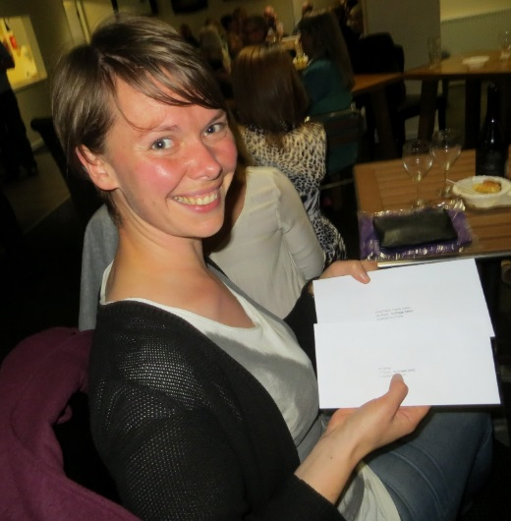
Liz Main Handicap and team Prizes
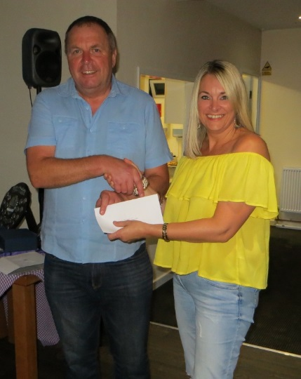
Rach Ladies Handicap

Yellow Jersey Competition

You have to complete all 10 races, if you can you are in a very good position to get a prize. Your times are added together. The smallest number is the winner. The male competition goes to 12th place and women to 6th (many more men than women) plus first in each vet categories get a prize.

We took 6 prizes in this race:
- 2nd Amanda
- 5th Sara
- 6th Jan
- FV35 Verity
- FV50 Jill
- FV60 Linda

Plus for running in all 10 races you get a T Shirt. “The T-shirt is a lovely purple polo shirt and mine is so comfy, I had to wear it all day on Sunday just to show off! Linda x”

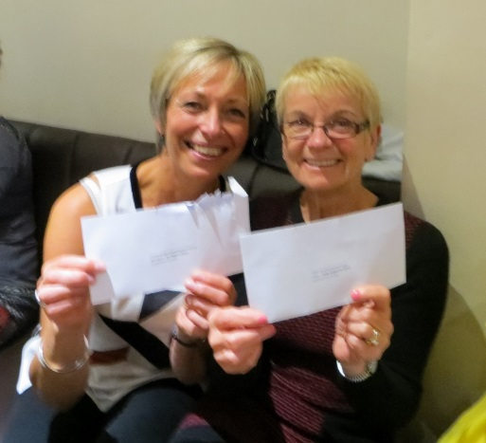
Liz main handicap & Team
Linda Yellow Jersey

Teams

Teams consist of 3 racers. In each race the two best handicap scores are added into the team score. The one with the biggest number of points wins. The top 5 teams get a prize.

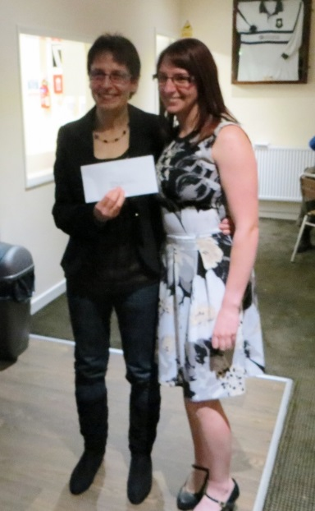
Jill Main & Ladies handicap,
Yellow Jersey, Team
Zoe Team

This year we had 5 teams which were carefully organised to ensure that there would always be two out of the team running.

This worked very well and two teams took a win which meant another 6 prizes:

- 1st Whiskey Chaser: Jill, Zoe & Sandra
- 3rd Hull Tiger: Jan, Liz & Jane

We were close to another 3 prizes as ‘Thunder Girls R Go’ were in 6th place.

Feedback from the WHL racers

Jan
This was the first time I'd run in the Champagne League and I loved it! Originally I was only able to make 7 of the 10 races - due to work commitments - but after the first race I changed work commitments so that I could run in all 10, that's how much I enjoyed it!
The handicap system means that not only are you racing against others, but that you are racing against yourself and I really benefitted from a fortnightly race that pushed me. The routes around the beautiful Yorkshire scenery were fantastic and some took me on new territory which is always a great thing. The camaraderie amongst all the runners - not just WHL, although there was lots of that too! - is great and you get to meet lots of other runners from other clubs and forge friendships.
So, if you're thinking about it for next year, let me encourage you and say 'give it a go!' It doesn't matter how fast or how slow you are - the handicap system makes us all equal!

Zoe

After missing the Champagne League last year I decided that I could not miss it again as I had enjoyed it the previous two years. I enjoy this league because I like running off road and in the nice countryside. I also enjoy the team spirit and camaraderie between our club and the other clubs that take part. There are many different categories and prizes to go for in the champagne league which means that you do not have to be a fast runner to win a prize. Most of the races are short (between 3 and 5 miles) which I find confidence building and it really brings on my running. There are some races which I do not like so much but overall I think it is a really good league and would encourage anyone to have a go. Everyone is very friendly and encouraging and it is a good opportunity to make lots of running friends.

Rachel W
I'm a big fan of off road running. I've done numerous Rudolph Romp Recces, including the 17 mile one 3 times but never actually done the race itself and have always fancied giving Champagne League a try but have been nervous about the commitment of having to run regularly and being part of a team. My running is a bit sporadic to say the least the majority of the time because of work, family etc., etc. Anyway I emailed in my interest of Champagne League but asked to be bottom of the list, looking at my work diary I thought I would be able to make 8 of the 10 races at the most but somehow I got a place...

So the first race came around, on home ground for me, along the foreshore, a route I have ran many, many times. It was freezing cold, we set off and I felt I did ok, I wasn't the last to finish, in fact I finished with Jill, something never to be repeated again, in all future races she was a speck in the distance!!! I couldn't make the 2nd race, due to personal not work reasons but the team competition didn't start until race 3 so not too much guilt yet... And one by one the races happened, it seemed that any work commitments that I had that might have stopped me getting to a race got cancelled, I raced home from Milton Keynes one Tuesday evening to get back in time to race, did the dreaded Wauldby Green 8 miler 3 days after completing the National 3 Peaks Challenge and even managed to pick up a few extra points here and there to help our team out. Unfortunately we just missed out on a prize but hey there's always next year.

The whole experience of Champagne was amazing, I have definitely improved over the course of the series, feeling like a 'proper runner' is great, meeting members of other running clubs is lovely but best of all is the fabulous team spirit of WHL, cheering on, encouraging, congratulating both our own members and those if other clubs. I heard it being commented on by other club members on several occasions and it made me so proud to be part of the team.

My only regret is that I missed that one race. It would have been nice to come away with at least a T Shirt but I'll know in advance for next year not to book anything in for a Tuesday night because I definitely hope to be back and would advise any ladies who are thinking of giving a it a try to do it, I'm sure you won't regret it.

Sandra

2015 was my third year of running the Champagne League and once again I thoroughly enjoyed it. There is nothing at all not to like except for the race that is run over Beverley Westwood. Zoe loves it and it is one I am not so keen on.

The League starts in spring and finishes in summer and is an excellent fortnightly run with people who like to run with great company and in scenic surroundings. It is also fantastic training.

I would encourage all ladies to enter - give it a go you have nothing to lose and everything to gain. If you don't like it which I would find hard to believe you don't have to do it the next year. You could actually come and help marshal which is also a great way to spend a Tuesday evening.

Linda
For any of you considering joining in the Champagne League I’d say ‘go for it’. It’s a wonderful League to be part of. There are ten races in all, the longest being race 8 which is mainly off road at Wauldby Green. The shortest is 3.6 miles which is Brantingham Chase (although that one takes in ‘that hill’)! They take place every other Tuesday as the Summer League in East Hull takes place alternative Tuesday evenings.

It doesn’t matter if you are a slower or faster runner, this series caters for all abilities. What it does do is help to improve your speed and stamina and you also get the opportunity to meet other runners from other clubs on a more regular basis and before you know it they are coming over to chat to you! You get to know who is on a par with you and watching the results you try and beat her on the next race, it is so much fun.

You also belong to a team, and we had five teams of three. My ‘team mates’ were Sara and Rach and we were called ‘The Champagne Super Novas’. As teams you gain points each race and if you beat your handicap you get extra.

After the CL you get to attend (for a small fee) the presentation evening. This was fab and made even more fantastic because WHL won so many prizes. For such a small club I think (and know) that we are awesome and the cheering on the evening when we picked up said prizes was amazing. Well done to everyone, I am so proud to be one of you. I've made some fantastic friends through WHL and I love the camaraderie we have together.

So girls come on join in and have some summer fun next year and see if we can beat the prizes we won this year. WHL rock.

Jill
I’ve done the Champagne League, which is a 10 race series, three times now. I didn’t do it last year due to injury, but it really is a great competition to take part in. The first year that I did it, I was not used to running off road and I have to say that I hated the first four races. This was partly due to the fact that I was running with an injured calf, which resulted in me missing the Brantingham chase race. When my injury cleared up and I started to get used to running on trails, I really started to enjoy the event. I got to know so many more people from the other clubs, and the encouraging atmosphere really started to rub off on me. I also got to know my West Hull Ladies team mates better, and was able to appreciate the great support they gave everyone. The icing on the cake that year was that Zoe, Verity and me as ‘Thunder Girls are go’ won the team award. The next year that I competed in this, whilst I did not get any awards, I was really happy that I completed all ten races which gave me the commemorative tee shirt. After missing a year, I decided to take part again this year, and it has really been a fabulous experience again. Apart from the camaraderie that I have already spoken about, it really improves your running. Doing a race every two weeks from April to July really makes you sharp and increases your speed and stamina. Every year that I have taken part, I have improved my times both in the champagne league series and in other races too, which is one good reason to have a go.

Another good reason to do this event is that whatever your speed, you have a chance to win prizes. This year, every one of our runners who took part in all ten races won a prize. There are a number of competitions. The Yellow jersey is the fastest time over the whole ten races…no chance for me here so I thought, but they also give out Veteran Prizes, and this year I won the Female Vet 50, mainly because I did 10 races and the Female Vet 50 who beat me, (our fabulous Jan Draper) was placed in the overall yellow jersey award. Speed freak Amanda was amazing in this too, coming second overall! There were a number of other ten race finishers who won their age award too, including Verity, Sara E, and Linda, which is pretty good as we are one of the smallest clubs competing in this league!

The Champagne League is essentially a handicap series, so you get points for doing a better time than you are predicted to do, in comparison to everyone else. This is why anyone can win. It doesn’t matter how slow or fast you are, you just have to show an improvement over what you are predicted to do. For me this year, I scored good points in a number of the races so was really pleased to be placed third in the overall handicap, which includes both male and female runners. There is also a ladies points trophy. This takes the best eight races into consideration, and much to my surprise, I actually won this trophy this year. A number of other ladies did really well here including the amazing Liz Draper, who ran really strongly despite interspersing the races with the odd marathon and Ultra run! Winning this means so much to me as I have never won a prize for an actual race or race series before…I’m actually in a state of shock to be honest! I don’t think it will ever happen again so I better enjoy this success while it lasts! (The shield is huge, it’s like a small dining table!). There is also a team award. Again West Hull Ladies did well in this with West Hull Tigers (Liz D, Jan D and Jane) coming third and Zoe, Sandra and myself coming first with Whisky Chasers!

Some people might be a bit worried about running on trails and also about doing the distances but actually most of the races are on relatively good ground and all but two are between three and five miles. The two longest are raced in handicap order, (slowest starts first). These are Wauldby Green, which is totally off road (8.4miles), which is not my favourite, as it is quite hilly and tough going, and I always seem to get blisters doing this, and Kiplingcoates, (6miles), mostly on the road and the old railway line. I like this one, as it suits my running, and I got a great handicap this year, and came about 6th overall. This gave me a very tough handicap for Wauldby Green however, which was the next race, and I got overtaken by most of the field in that one lol!...it’s a bit scary being chased by loads of fast guys in these two races though (…although perhaps I should appreciate being chased by lots of muscular men, because it’s the only time it happens lol!). For the other races I like the South Dalton race, which is about five miles on road, and goes through the Dalton estate (fab scenery); plus both Lockington races, although I had to do the first one two days after the London Marathon, on very tired legs (Marathon waddle speed only, so I was almost last!). I also like both the Humber Foreshore and North Cave races which are really short, although this year I was recovering from a bit of a cold so tried to be quite steady. I have a love hate relationship with both the Beverley Westwood race and the Brantingham chase (both short races), as they are both pretty hilly! For me it’s the downhills that I dread, although for Brantingham…all I would mention is ‘Spout Hill’ (say no more!).

The main thing that comes out of this for me is that, you don’t have to be fast to do this race series, in fact the winner of the overall Champagne League this year was a woman who was in the last few runners in terms of speed, but won on the basis of consistency and improvement. In some ways slower runners who are likely to improve, have a great chance to do well in the Champagne League. We have been given more places for 2016 (18 places, which is six teams). We can often sort out lifts to the events between us all, so come on…have a go…you won’t regret it and you’ll have a great time!

The Races 2015
Date | Venue | Distance | Registration
31st March | Hessle Foreshore | 4 miles | Car Park Country Park Inn
7th April | North Cave | 4.0 miles | North Cave, Hotham Park
14th April | Beverley Westwood | 3.3 miles | Newbald Road
28th April | Lockington | 4.0 miles | Village Hall
12th May | Brantingham Chase | 4.0 miles | Brantingham Village Pond
26th May | Wauldby Green | 3.8 miles | Raywell
9th June | Kiplingcotes * | 6.0 miles | Grannie’s Attic
23rd June | Wauldby Green * | 8.4 miles | Raywell
7th July | South Dalton | 5.1 miles | Kiplingcotes X Roads
21st July | Lockington | 4.3 miles | Village Hall
* Reverse handicap race (slowest off first)

2015 RACE DIARY
http://westhullladies.org.uk/races.htm

Free 5K time trial every Saturday 9am: Hull Parkrun or Peter Pan Parkrun Humber Bridge parkrun

Date/Time | Event | Fee | Entry forms | Online entry
September 2015
 | 13th/09:00 | Hull Marathon | £35 UKA/£37 | Online entries only | online entry
 | 20th/12:00 | Subway Helping Hearts Family 5K (Sheffield) | £6.99 | Online entries only | online entry
 | 20th/09:30 | Vale of York Half Marathon | Race Full | Race Full | Race Full
 | 27th/10:00 | Isle of Axholme Half Marathon | £16 UKA/£18 | Online entries only | online entry
 | 27th/11:00 | Bishop Burton College Canter 7 Mile | £10 UKA/£12 | Online entries only | online entry
 | 27th/09:30 | Ikano Robin Hood Marathon | Race Full | Race Full | Race Full
 | 27th/09:30 | Ikano Robin Hood Half Marathon | Race Full | Race Full | Race Full
October 2015
 | 4th/09:30 | Huddersfield Hilly Half Marathon | £20 | Online entries only | online entry
 | 11th/10:00 | Yorkshire Coast 10K | Race Full | Race Full | Race Full
 | 17th/11:00 | Gruesome Twosome Half Marathon | £19 UKA/£21 | Entry form | Postal entries only
 | 18th/10:00 | Bridlington Half Marathon | £13.50 UKA/£15.50 | Entry form | online entry
 | 25th/11:00 | Brigg Poppy 10K | £15 UKA/£17 | Online entries only | online entry
 | 25th/11:00 | Haltemprice 10K | £7 UKA/£9 | Entry form | Postal entries only
November 2015
 | 1st/TBC | Deep Dale Dash | £15 UKA/£17 | Online entries only | online entry
 | 1st/10:30 | Guy Fawkes 10 Mile | £14.70 UKA/£16.70 | Online entries only | online entry
 | 8th/11:00 | Dalby Dash 10K | £11 UKA/£13 | Online entries only | online entry
 | 15th/09:30 | Leeds Abbey Dash 10K | £22 UKA/£24 | Online entries only | online entry

Please remember to double check dates, times and entry fees with the official website or the entry form.

Keep checking the website for new races and updates:

NOTE: Club Vests must be worn at any races you enter
under the West Hull Ladies running club name.

West Hull Ladies Road Running Club
Kit Order Form

NEW STYLE VESTS are purchased direct from www.pbteamwear.co.uk
On website: click on Clubs, Athletics Club, West Hull Ladies RC
Pick your size, name you wish to have on the front and follow payment instructions

For all other purchases use this form.

FORENAME ___________________________________

SURNAME ___________________________________

ORDER - tick what you require and circle your size Price
- OLD STYLE VEST SIZE 10 12 14 16 £10.00 (useful for training)
- LONG SLEEVED SIZE 10 12 14 16 £18.50
- HOODIE SIZE XS S M L £20
- HOODIE with ZIP SIZE XS S M L £20
Note on size: M is approximately size 14
- BEANIE HAT £6.50
- PINLESS WHL NUMBER FASTENERS (set of 4) £3.00

DATE Ordered _______________
AMOUNT PAID _______________

Please transfer payments online with your name and marked as ‘Kit to:
Account: 63762742 Sort Code: 20 43 49

Or cheque payable to ‘West Hull Ladies RRC’, and write your name and ‘Kit’ on the back and give to Club Treasurer Linda Dodsworth, 110 The Stray, South Cave, E Yorkshire. HU15 2AL

Sign on receipt of goods _________________________________
DATE _______________

Please complete this form and email to diazmaria@btinternet.com
Thanks.
Maria Kit Officer

